**Topic 4 Assignment / Chapter 10**

**Windows Programming & CIS-2225**

|  |  |
| --- | --- |
| Author: | Christopher Sigouin |
| Date: | October 22, 2015 |
| Due Date: | October 26, 2015 |
| Assignment: | Topic 4 Chapter 10 |
|  |  |
|  |  |
| Mark: | __________ |

|  |  |
| --- | --- |
|  | CIS-2225 Windows Programming |

Topic 4

|  |  |
| --- | --- |
| To: | Gerald Caissy |
| From: | Christopher Sigouin |
| Date: | October 22, 2015 |
| Subject: | Pizza Delivery Company |
|  |  |

This assignment was to produce a Windows based application for a ‘Pizza Delivery Company’. It should be understood that this application represents something that the actual pizza company (who takes client orders for the pizza products) would use on a daily basis. It includes delivery options as well. Details regarding the application requirements are posted below.

*Complete and Submit Chapter 10 Programming Exercise 10 'Pizza Delivery Company'. Plus: Use a Class to hold Order Information and Customer Contact Information. The calculation should be within the order class or in a completely separate business layer class object. The form designed for the final order confirmation, must have a print option.*

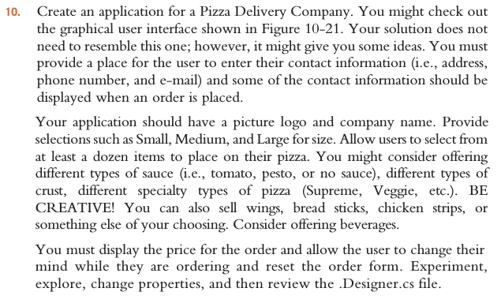

Some assumptions and constraints were created for the application as the business requirements specificity level was not high enough. The following should be taken into consideration:

* + *The fact that the requirements specified to include “pizza toppings“, led me to believe that the application was to be utilized by the actual pizza restaurant. I would not think a delivery company would care that the pizza had toppings at all. Therefore, this application is geared more towards the restaurants usage.*
  + *The application can only handle one order at a time and must be reset to process a new order. It is prebuilt to be scalable (utilizing an array of orders) but only the first element is used in the application.*
  + *Enumerations are heavily used to allow ease of adding a new type of product, should the situation present itself.*
  + *A customer cannot add ‘extra’ toppings to a pizza (i.e. two instances of bacon). They can have one of each type of topping only.*

A class diagram was designed to show the structure of the application as well. Not all of the attributes/behavior is documented in this diagram.

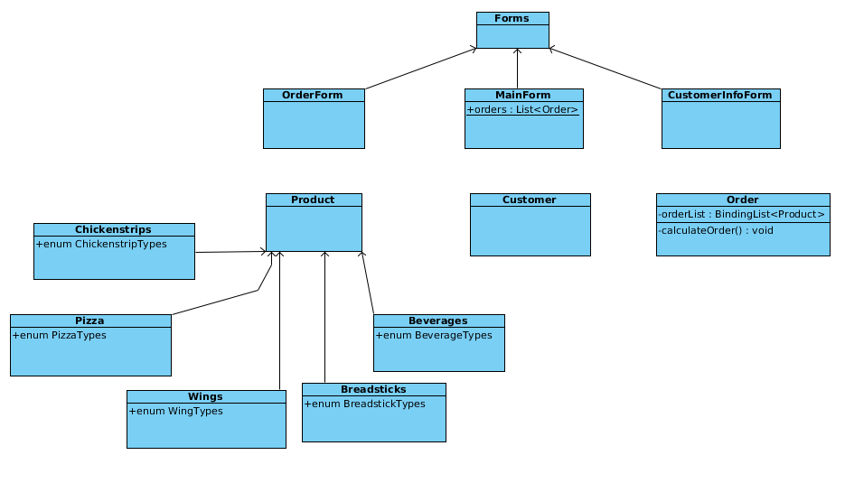

The attributes and methods defined within the class diagram are based from the above business requirements.

BASIC WORKFLOW:

* 1. User opens application and presses “Place Order”
  2. User selects products from tab controlled areas and selects “Add”. This will
  3. add the product to the ‘Order List’ on the right.

*The order screen has two modes. ‘Add Mode’ and ‘Edit Mode’.*

*Items that are displayed in the ‘Order List’ can be edited by single clicking on the item. When they are clicked, the tabs that are irrelevant to the selection will be removed, leaving the single tab with the selection pre-loaded. The ‘Add’ button will change to ‘Add (Edit Mode)’ indicating its use.*

*When in ‘Edit Mode’ A user can use the same choice or choose a new choice and then press “Add (Edit Mode)”. This will update the order that is current.*

* 1. User selects ‘Save Order’ and the form closes showing the main screen again. When this button is selected, it will enable the button ‘Customer Info’.
  2. User selects ‘Customer Info’. This opens a new form to allow entry for customer information.
  3. User clicks on ‘Save Customer’. This will close the form and enable the ‘Delivery Options’ group box displayed on the main form.
  4. User selects a delivery option (Yes or No). This will enable ‘Display Details’.
  5. User presses ‘Display Details’. This loads the details of the order that include the following:

*Product Details*

*Customer Information*

*Pricing*

* 1. User presses ‘Reset Order’. This will clear the order out of the application.

|  |  |
| --- | --- |
| **PRICING CHART** | |
| Pizza | |  |  | | --- | --- | | Size – Small | $10 | | Size – Medium | $15 | | Size – Large | $20 | | Each Topping | $0.50 | |
|  |  |
| Wings | |  |  | | --- | --- | | BBQ | $9 | | Honey Garlic | $10 | | Suicide | $9.50 | |
|  |  |
| Breadsticks | |  |  | | --- | --- | | Plain | $3 | | Whole Wheat | $3 | | Cheese | $4 | |
|  |  |
| Chicken strips | |  |  | | --- | --- | | White Meat | $8 | | Dark Meat | $7 | |
|  |  |
| Beverages | |  |  | | --- | --- | | Soda Pop | $1 | | Water | $0.50 | |